Universal design is a broad concept that is defined by The Center for Universal Design at North Carolina State University as "the design of products and environments to be usable by all people, to the greatest extent possible, without the need for adaptation or specialized design."
Sidewalks with curb cuts and doors that automatically open when a person moves near them are examples of universally designed products. They benefit people with disabilities, parents with baby strollers, delivery workers, and others. Human characteristics considered in universal designs may include age, gender, stature, race/ethnicity, culture, native language and learning preference.
- www.washington.edu
The Finger Lakes Independence Center
215 Fifth Street
Ithaca, NY 14850
Phone: 607.272.2433
Fax: 607.272.0902
www.fliconline.org
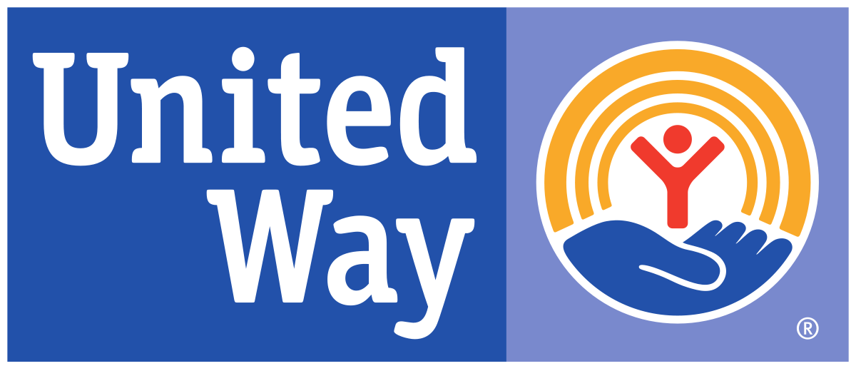
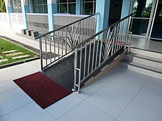

& Accessibility Consultations
Modular Ramp Program
Additional Accessibility Resources

Ithaca Neighborhood Housing
Call: 607.277.4500
www.ithacanhs.org

Bishop Sheen Housing
(585) 657-4114
Sheen2@rochester.rr.com

Disability and Health Home Call:1.800.cdc.info
TTY: 1.888.232.6348
www.cdc.gov/ncbddd/disabilityandhealth/disability-barriers.html

Americans with Disabilities Act Checklist for Ready Achievable Barrier Removal
Call: 1.800.949.4ADA
www.ada.gov/racheck.pdf

To learn more about the Principles of Universal Design
www.idea.ap.buffalo.edu/

Finger Lakes Independence Center
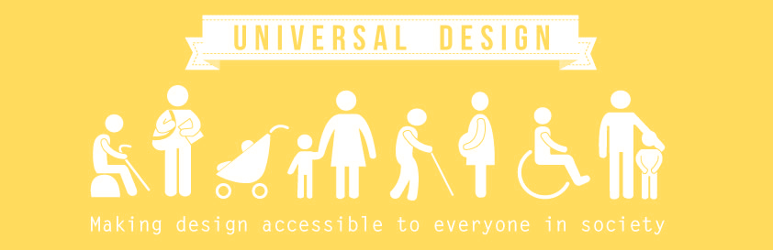
Call us today to find out more about our modular ramp loan program or our free accessibility consultations for your home or business.

Temporary Ramp Loan Program
Modular ramp systems are available for temporary installation by our skilled staff. If you or someone you know needs a ramp to access their home, please call The Finger Lakes Independence Center today. Our ramp program is open to residents of Tompkins County. A refundable deposit is required. Currently our Ramp Loan Program is available in part because of grants we have received from the Ithaca Urban Renewal Agency, the United Way of Tompkins County, the Rotary Club of Ithaca and individual donations.
Purpose of the Ramp Program at FLIC:
“To remove barriers to home egress and access for people with mobility disabilities through the installation of ramps at no cost to income-eligible individuals or family in need of a ramp at their home. Applicants much meet low to moderate income guidelines provided by the Ithaca Urban Renewal Agency that provides some funding for the Ramp Program.”
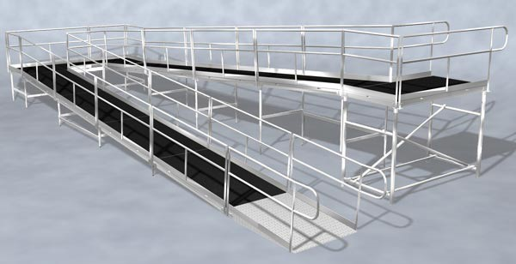

Note to individual making inquiry:
-Must be income-eligible to participate in the Ramp Loan Program.
City of Ithaca CDBG Income Limits
Family Size | Moderate income limit | Low income limit 60% | Low income limit | Very low income limit
1 | $47,000 | $35,280 | $29,400 | $17,650
2 | $53,700 | $40,320 | $33,600 | $20,150
3 | $60,400 | $45,360 | $37,800 | $22,650
4 | $67,100 | $50,340 | $41,950 | $25,150
5 | $72,500 | $54,420 | $45,350 | $27,200
6 | $77,850 | $58,440 | $48,700 | $29,200
7 | $83,250 | $62,460 | $52,050 | $31,200
8 | $88,600 | $66,480 | $55,400 | $33,200
-The Ramp Specialist will call to assess need and availability.
-There is a $125 refundable deposit to participate. Deposit will be deposited when ramp is installed and refunded when ramp is uninstalled.
-There is no time limit for the loan period. A person can use the ramp as long as they need it. We ask that you let us know as soon as possible when you no longer need the ramp, so that it can be put into use for someone else in need.
-To maintain a spot on the waiting list, FLIC needs current address and contact information for the borrower. If any information changes, FLIC needs to be updated with that information.
- The needs of the people on the list are met on a first come, first served basis and depends on ramp availability.
-When a person calls in need of a ramp we will give them information for other available programs they may be qualified for. We give this information to ensure that people are provided with ramps as soon as possible. It is up to the person requesting the ramp to follow through with these referrals to other programs.
-There is not a predictable way to determine how long someone may be on the list before receiving a ramp because of the variables that affect ramp availability.
-Other ramp and accessibility modification programs may be available by contacting:
- INHS at 607-277-4500
- Better Housing at 607-273-2187
- Bishop Sheen Housing at 585-657-4114
Accessibility Consultation
Removing architectural barriers is key to creating an inclusive community and supporting people with disabilities to lead independent lives. We provide assistance to individuals, business owners, schools, and government agencies to help make physical spaces accessible.
Call Brian at the Finger Lakes Independence Center 607.272.2433 or his direct line 607.342.5193 or e-mail brian@fliconline.org for more information.

