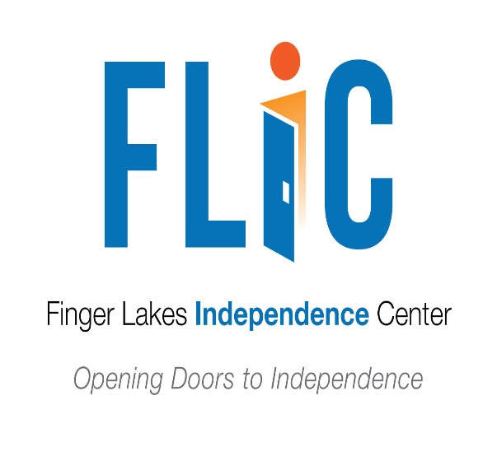
If you have any additional questions, please call the Finger Lakes Independence Center at 607-272-2433 or your regional ADA Center for more information at 1-800-949-4232.
The ADA requires all buildings and facilities that are open to the public to be accessible. This includes temporary structures that are extensively used by or are essential for the public use at an event.
The Architectural Barriers Act (1968) - This Act stipulates that most buildings, other than privately-owned residential facilities, constructed by, on behalf of, or leased by the United States, or buildings financed in whole or in part by the United States, must be physically accessible for people with disabilities.
Section 504 of the Rehabilitation Act (1973) - Under this Section, no qualified individual with a disability may be discriminated against in any program or activity receiving federal financial assistance.
State and Local Codes – Many states have developed their own building codes for accessibility. Organizers need to know about both federal law and state/local codes that may apply to their events.

Accessibility Checklist
Can someone with a disability-
- Find and use accessible parking
- Get from accessible parking to entrances
- Obtain information and directions prior to the event
- Move around the site as needed
- Use public toilet rooms, telephones, water fountains, shelters, first aid stations, and other common amenities
- Attend performances, participate in activities, and enter exhibits
- Select and purchase items at concessions
- Experience and enjoy activities, even if the participant’s disability affects their ability to communicate

Making Temporary Events Accessible
The Finger Lakes Independence Center
215 Fifth Street
Ithaca, NY 14850
607.272.2433
www.fliconline.org
Durable Medical Equipment available for short-term loan.

Are you planning a local festival, craft fair, music event, sporting event or home show?

Ways to remove barriers
- Rearrange tables, chairs, vending machines, display racks, and other furniture
- Create designated accessible parking spaces

Preparing Staff and Volunteers
- View an individual in terms of the whole person and not just the disability.
- Avoid being anxious or overly protective; people will let you know what they need.
- Some people will need extra time to move, speak, perform a task, or participate in an activity
Vendors
- Ensure that people with disabilities will have comparable access to food, drinks, merchandise, or services offered. For example, a vendor may need to take items from an inaccessible area to an interested individual in order to allow the individual to evaluate and select merchandise or to participate in an activity offered.

Types of disabilities to consider when preparing a local event
- Mobility Disabilities
  - Wheelchair Users
  - Ambulatory Mobility Disabilities
- Visual Disabilities
- Hearing Disabilities
- Cognitive Disabilities and Other Hidden Disabilities

Plan Early and Review Often

Consider having the following point persons
Accessibility Coordinator-An effective strategy for managing accessibility efforts is to designate an “accessibility coordinator” to oversee all phases of the event, from planning to completion. This role is especially important for larger events where many diverse elements must be managed.

Advisors- Invite participation of individuals with various disabilities early on to help with site selection and other concerns.

Disability Organizations- Local and national disability groups and organizations can help you find services such as sign language interpreters or renting equipment such as assistive listening systems or portable ramps.

Architectural Accessibility Consultants. Accessibility consultants are a source of advice and information, particularly for solutions to specific architectural barriers.

Contact Finger Lakes Independence Center with questions and for further assistance (607) 272-2433

The ADA states that people with disabilities must be able to obtain or enjoy “the same goods, services, facilities, privileges, advantages, or accommodations” that are provided to other members of the public.

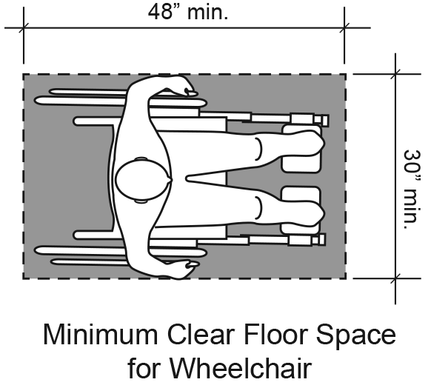
A space that is a minimum of 30 inches wide by 48 inches long is necessary to park a wheelchair in a stationary position.

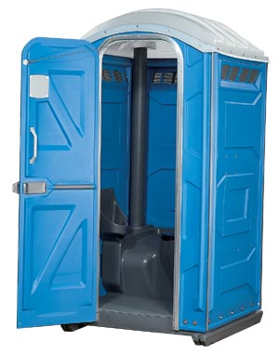
If portable toilets are provided for use by event participants, a minimum of five percent of all units, but never less than one unit, must be accessible.

