Ramps, Railings, Elevators, Doorways, Homes, Businesses, Visitability, Accessibility, Medical Equipment, Assistive Devices, Consultation. Ramps, Railings, Elevators, Doorways, Homes, Businesses, Visitability, Accessibility, Medical Equipment, Assistive Devices, Consultation. Ramps, Railings, Elevators, Doorways, Homes, Businesses, Medical Equipment, Assistive Devices, Consultation.

The Finger Lakes Independence Center
215 Fifth Street
Ithaca, NY 14850
Phone: 6071272.2433
Fax: 607.272.0902
www.fliconline.org
& Modular Ramp Program
Architectural Barrier Consultations
Additional Accessibility Resources

Better housing of Tompkins County
Call: 607.277.4500 Chris Carreiro
www.betterhousingtc.org

Disability and Health Home Call:1.800.cdc.info
TTY: 1.888.232.6348
www.cdc.gov/ncbddd/disabilityandhealth/disability-barriers.html

Americans with Disabilities Act Checklist for Ready Achievable Barrier Removal
Call: 1.800.949.4ADA
www.ada.gov/racheck.pdf

To learn more about the Principles of Universal Design
www.ncsu.edu/ncsu/design/cud/
www.idea.ap.buffalo.edu/

Ramps and Other Accessibility Equipment (for Purchase or Rental)
Call: 1.570.882.7436
www.maximummobility.net

Finger Lakes Independence Center
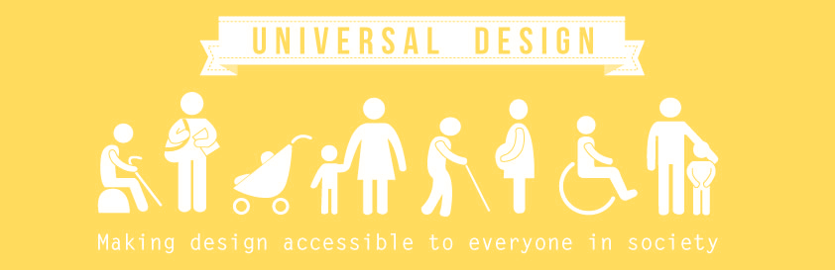
Call us today to find out more about our modular ramp loan program or our free accessibility consultations for your home or business.

Temporary Ramp Loan Program
Modular ramp systems are available for temporary installation by our skilled staff. If you or someone you know needs a ramp to access their home please call The Finger Lakes Independence Center today. Our ramp program is open to residents of Tompkins or Schuyler Counties. A refundable deposit is required. Currently our Ramp Loan Program is available in part because of grants we have received from the Ithaca Urban Renewal Agency and individual donations.

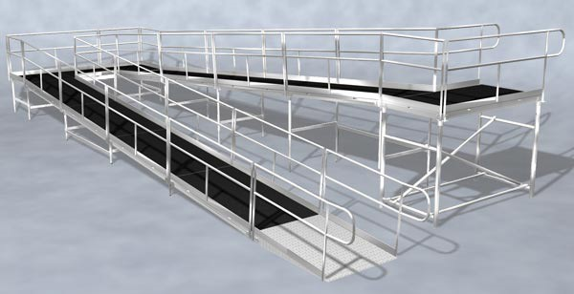

Accessibility Consultations
Removing architectural barriers is key to creating an inclusive community and supporting people with disabilities to lead independent lives. We provide assistance to individuals, business owners, schools, and government agencies to help make physical spaces accessible. We can also review architectural plans prior to construction.
Call Scott at the Finger Lakes Independence Center or e-mail scott@fliconline.org for more information.

Universal Design
The term "universal design" was coined by the architect Ronald L. Mace to describe the concept of designing all products and the built environment to be aesthetic and usable to the greatest extent possible by everyone, regardless of their age, ability, or status in life.
- www.ncsu.edu
Universal design is a broad concept that is defined by The Center for Universal Design at North Carolina State University as "the design of products and environments to be usable by all people, to the greatest extent possible, without the need for adaptation or specialized design."
Sidewalks with curb cuts and doors that automatically open when a person moves near them are examples of universally designed products. They benefit people with disabilities, parents with baby strollers, delivery workers, and others. Human characteristics considered in universal designs may include age, gender, stature, race/ethnicity, culture, native language and learning preference.
- www.washington.edu

